Task No 01: Find the company’s name that placed order 10290. (Tables: Customers & Orders).

Solution:

USE Northwind;

SELECT c.companyName

FROM Customers c

JOIN orders o ON c.customerID = o.customerID

WHERE o.OrderID = 10290;

Output:



Task No 02: Create a report that shows the product name and supplier id for all products supplied by Exotic Liquids, Tokyo Traders, Ma Maison and Lyngbysild. (Tables: Products & Suppliers)

Solution:

USE Northwind;

SELECT p.ProductName, p.SupplierID

FROM Products p

JOIN Suppliers s ON p.SupplierID = s.SupplierID

WHERE s.CompanyName IN ('Exotic Liquids', 'Tokyo Traders', 'Ma Maison', 'Lyngbysild');

Output:

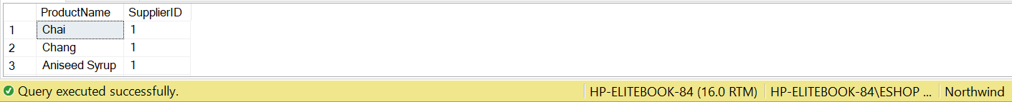

Task No 03: Create a report that shows all products by name that are in the Confections. (Tables: Products & Categories)

Solution:

USE Northwind;

SELECT p.ProductName

FROM Products p

JOIN Categories c ON p.CategoryID = c.CategoryID

WHERE c.CategoryName = 'Confections';

Output:

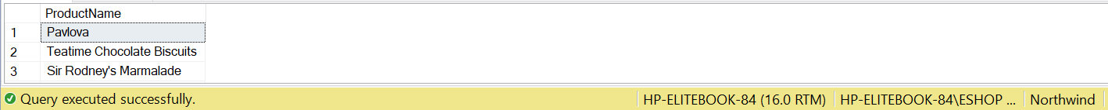

Task No 04: Retrieve name of product having maximum, minimum and average unit price along with their prices. (Tables: Products)

Solution:

USE Northwind;

SELECT

ProductName,

UnitPrice

FROM

Products

WHERE

UnitPrice = (SELECT MAX(UnitPrice) FROM Products)

OR UnitPrice = (SELECT MIN(UnitPrice) FROM Products)

OR UnitPrice = (SELECT AVG(UnitPrice) FROM Products);

Output:

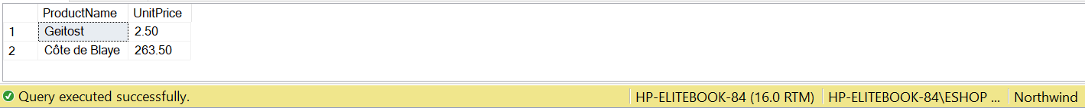

Task No 05: Create a report that shows all 5 companies by name that sell products in the Seafood category. (Tables: Suppliers, Products & Categories)

Solution:

USE Northwind;

SELECT DISTINCT s.CompanyName

FROM Suppliers s

JOIN Products p ON s.SupplierID = p.SupplierID

JOIN Categories c ON p.CategoryID = c.CategoryID

WHERE c.CategoryName = 'Seafood';

Output:

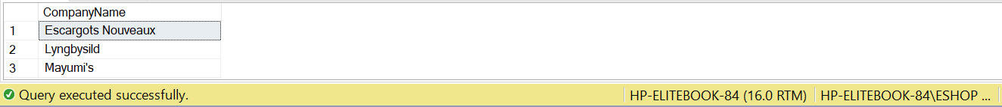

Task No 06: Write query using a “sub query” to display which Customers were served by which Employee. (Tables: Customers & Employees)

Solution:

USE Northwind;

select c.CustomerID, c.contactName, o.EmployeeID, e.firstNAme

from Customers c join Orders o on o.CustomerID = c.CustomerID

join Employees e on e.EmployeeID = o.EmployeeID

where c.customerID in (select customerID from Orders);

Output:

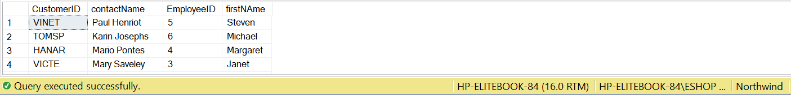

Task No 07: Write query using a “sub query” to list of all the stores that have discount records (use pubs).

Solution:

USE Northwind;

SELECT DISTINCT store.stor_name

FROM stores store

JOIN sales sale ON store.stor_id = sale.stor_id

WHERE sale.discount > 0;

Output:

Task No 08: Write query using a “sub query” to list all the authors available in Barnum’s store (use pubs).

Solution:

USE Northwind;

Select au_id, au_fname from authors where au_id in

(Select au_id from titleauthor where title_id

in(select title_id from sales where stor_id

in(select stor_id from stores where stor_name = 'Barnum''s')));

Output:



Task No 09: Write query using a “sub query” to give the customer id and amount spent of the customer who spent the most.

Solution:

USE Northwind;

select c.customerID , (od.unitprice * od.quantity) from customers c join orders o

on o.CustomerID = c.CustomerID join [Order Details] od

on od.OrderID = o.OrderID

where (unitprice * quantity) =

(select max(unitPrice * Quantity) from [Order Details]);

Output:



Task No 10: Write a query using a “sub query” to find customers who have placed orders. (Tables: Customers &

Orders)

Solution:

USE Northwind;

select customerID, ContactName from Customers

where CustomerID in (select CustomerID from Orders);

Output:

